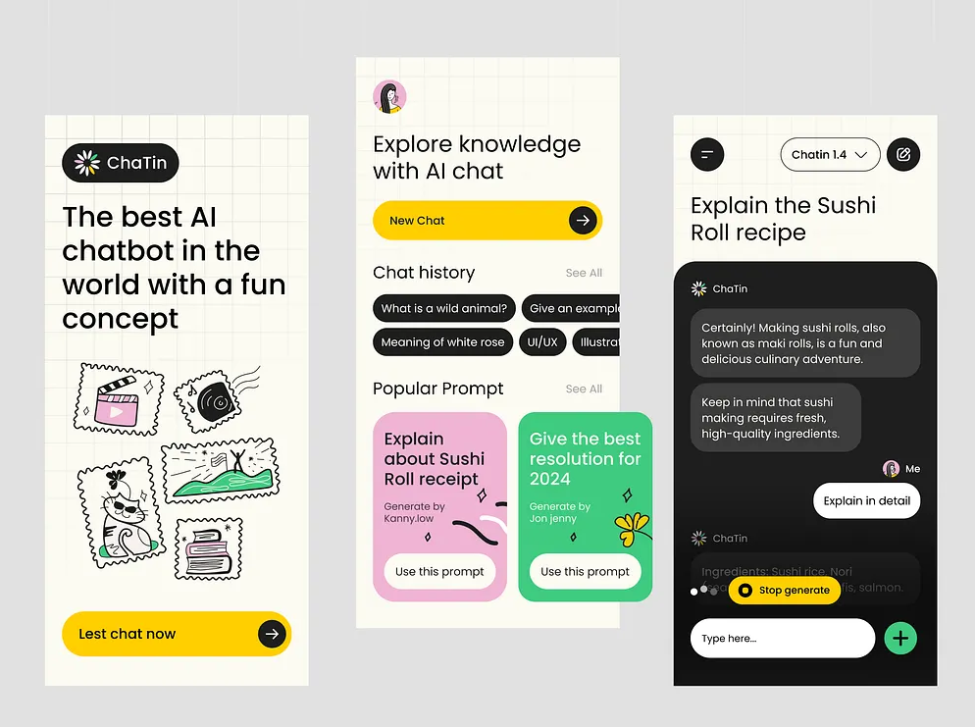
the design of our project must be looks like this, take this as an inspiration

